

**Plants That Naturally Deter Mosquitoes**

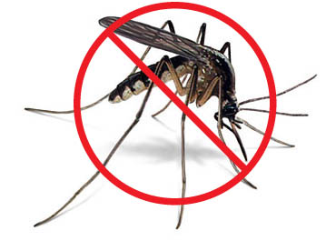

**HERBS**

Citronella (Geranium)

Lemon Grass

Rosemary

Lavender

Lemon Thyme

Catnip

Catmint

Lemon Balm

Basil

Mint

Bee Balm (Monarda)

Lemon Verbena

Eucalyptus (Lemon or Silver)

Garlic

Mexican Mint Marigold

Nasturtium

**FLOWERS**

Marigolds

Blue Ageratum (In Spring)

Agastache (Hummingbird Mint)

Artemisia

Lantana

Revised 6/8/18