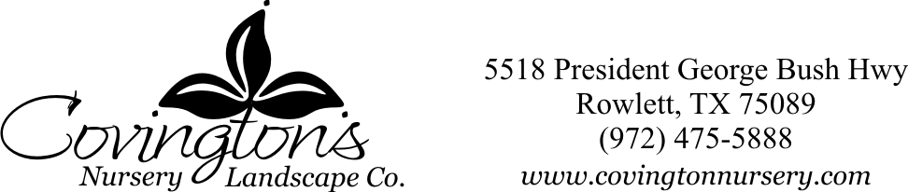

**Butterfly Nectar Plants**

As the name suggests, these plants are the ones that attract mature butterflies to feed on nectar, which is their primary source of food in this last stage of their life.

|  |  |  |
| --- | --- | --- |
| Abelia | Dianthus | Penstemon |
| Agastache | Esperanza | Pentas |
| Aster | Firebush | Phlox |
| Autumn Sage (Salvia Greggii) | Gaillardia | Pincushion Flower |
| Bee Balm (Monarda) | Gayfeather | Rudbeckia |
| Black-eyed Susan | Gomphrena | Sages & Salvias (various) |
| Blackfoot Daisy | Heuchera (Coral Bells) | Scarlet Sage |
| Butterfly Bush | Honeysuckle | Sedum |
| Candytuft | Lantana | Shasta Daisy |
| Carolina Jessamine | Lavender | Spirea |
| Citrus trees | Lobelia | Sunflower |
| Columbine | Marigolds | Turk’s Cap |
| Coneflower | Mexican Mint Marigold | Verbena |
| Coreopsis | Milkweed (Butterfly Weed) | Vitex |
| Daylily | Mist Flower | Yarrow |
| Desert Willow | Nepeta | Zinnia |

**Butterfly Host Plants**

If gardener wishes to support the butterfly populations from beginning to end, then host plants need to be incorporated into the landscape. Host plants are the plants on which adult butterflies lay their eggs and on which the caterpillars feed.

|  |  |  |
| --- | --- | --- |
| Althea (Rose of Sharon) | Dill | Parsley |
| Asters | Dutchman’s Pipevine | Pineapple Sage |
| Bird-of-Paradise (*Caesalpinia gilliesii*) | Fennel | Passion Vine |
| Black-eyed Susan | Flame Acanthus | Plumbago |
| Candle Tree | Gaillardia | Rose Mallow (Hardy Hibiscus) |
| Cannas | Inland Sea Oats | Rue |
| Citrus Trees | Mexican Petunia | Texas Sage |
| Cleome | Mexican Plum Tree | Wisteria |
| Coneflower | Milkweed (Butterfly Weed) | Yarrow |

6/20/17